Change Order Request

July 13, 2016

Chinn Construction, LLC
14715 NE 95th Street, Suite 101
Redmond, WA 98052
Attn: Charlie Poggemann

Re: Hadley Apartment Project – Change Order Request – RFI-308Rev1 Lav Sink

Charlie,

Per RFI-308rev1, we have been directed to install a Nameeks Scarabeo 8025/D lav sink in unit 201. This is a very specialty sink. One Way Plumbing total cost for this lav sink and associated labor is $872 + 10% OH&P = $959. I’ve excluded countertop cutout. Please issue an official Change Order at your earliest convenience.

Let me know if you have any questions or comments. Thank you.

Sincerely,
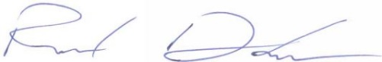
Richard Donelson
Project Manager / Estimator
LEED® Green Associate
richd@owpllc.net
425-591-4296 cell

